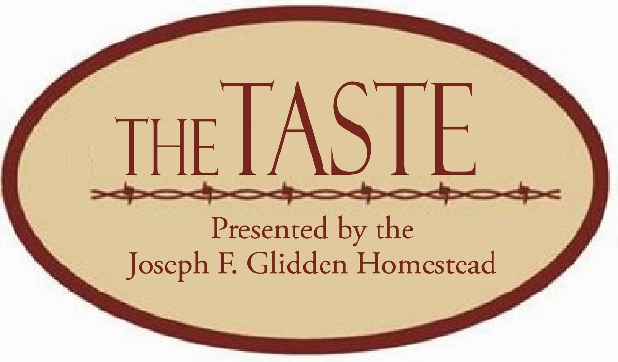
‘The Taste’ formerly DivasDish
presented by
The Glidden Homestead
Saturday, April 22, 2017 www.gliddenhomestead.org

☐ YES! I want to be a chef for ‘The Taste’.
☐ No Thanks; I’m not interested right now. Please ask me again next year.

NAME: Click here to enter text.

ADDRESS: Click here to enter text.
CITY: Click here to enter text. EMAIL: Click here to enter text. (REQUIRED)
HOME PHONE: Click here to enter text. OTHER NUMBER: Click here to enter text.

Please list 2 options for what you would like to cook (Old-time/historic Family Recipes Encouraged):
1ST CHOICE: Click here to enter text.
CATEGORY: Choose an item.

2nd CHOICE: Click here to enter text.
CATEGORY: Choose an item.

DO YOU NEED ELECTRICITY OR BURNERS? Click here to enter text.
WHAT OTHER SUPPLIES WILL YOU NEED? Click here to enter text.
☐ YES, I will donate a Silent Auction item (can be baked items) OR other item
Please fill out this form and fax to (815) 756-7904; e-mail it to info@gliddenhomestead.org; or mail to: The Taste, Glidden Homestead, 921 W. Lincoln Hwy., DeKalb IL 60115 by March 31, 2017. You will be provided with a timeline and information on safe food handling practices. All chefs are responsible for purchasing their own food and supplies. The 250 samples should be prepared before you arrive.

The event hours are 5:30-8 p.m., Saturday, April 22. Chefs should arrive between 4-4:30 p.m., for set up. The
Chef’s reception will begin at 4:45 p.m., to allow Chefs to taste each other’s dishes. Please bring your food items with you and a helper to serve your dish while you mingle. We encourage you to decorate your table if you would like to do so. We encourage each Chef to sell at least 4 tickets to the event. Each chef is asked to stay for the entire evening to meet and greet people and give information on their dish.

